Frontend Development with React.js

Project Documentation format.

InsightStream: Navigate the News Landscape

# 1. Introduction

**Project Title:** InsightStream: Navigate the News Landscape  
  
**Team Members:**   
 Team Leader Name: J P RAGHUL[crazyraghul1320@gmail.com]

Team Member Name: DHANUSH KUMAR E [dhanushkumar63811@gmail.com]

Team Member Name: VINITH D[vinith9871@gmail.com]

Team Member Name: DEEPAK P[deepakpdeepakp75@gmail.com]

Team Member Name: PRAVEEN KUMAR T [smileypraveen1234@gmail.com]

# 2. Project Overview

**Purpose:**  
  
InsightStream is designed to provide users with a seamless news browsing experience. It aggregates the latest news articles from various sources, allowing users to explore trending stories, filter by category, and bookmark their favorite content.  
  
**Features:**  
  
- Dynamic News Feed with Real-Time Updates  
  
- Category-Based Filtering (Politics, Sports, Tech, etc.)  
  
- Search Functionality for Finding Specific News  
  
- Bookmark Feature to Save Favorite Articles  
  
- Responsive Design Optimized for All Devices  
  
- Light/Dark Mode for Enhanced User Experience

# 3. Architecture

**Component Structure:**  
  
**App.js** - Root component that handles routing and layout  
  
 **Header.js** - Navigation bar with search functionality  
  
 **NewsList.js** - Displays categorized news articles  
  
 **NewsCard.js** - Individual news item with title, image, and description  
  
 **NewsDetails.js** - Detailed view of a selected news article  
  
 **Footer.js** - Provides additional links and site information  
  
  
**State Management:**  
  
- Context API - Manages global state for theme settings, bookmarks, and search data  
  
  
**Routing:**  
  
- React Router - Implemented for seamless navigation between pages

# 4. Setup Instructions

**Prerequisites:**  
  
- Node.js (v18 or higher)  
  
- npm or yarn  
  
  
**Installation:**  
  
1. Clone the Repository:  
  
git clone https://github.com/darunraj0071/insightstream-news-app.git  
  
cd insightstream-news-app  
  
  
2. Install Dependencies:  
  
npm install  
  
  
3. Create .env file (for API keys or environment variables):  
  
REACT_APP_NEWS_API_KEY=your_api_key_here  
  
  
4. Run the Application:  
  
npm start

# 5. Folder Structure

/src  
  
├── /components  
  
│ ├── Header.js  
  
│ ├── NewsList.js  
  
│ ├── NewsCard.js  
  
│ ├── NewsDetails.js  
  
│ └── Footer.js  
  
├── /pages  
  
│ ├── Home.js  
  
│ ├── Categories.js  
  
│ └── Bookmarks.js  
  
├── /assets  
  
│ ├── images  
  
│ ├── icons  
  
│ └── styles  
  
├── /utils  
  
│ ├── api.js  
  
│ ├── helpers.js  
  
│ └── constants.js  
  
├── App.js  
  
└── index.js

# 6. Running the Application

**Frontend Server Command:**  
  
npm start

# 7. Component Documentation

**Key Components:**  
  
 **Header:** Displays navigation bar and search bar  
  
 **NewsList:** Fetches and renders categorized news articles  
  
 **NewsCard:** Displays individual news article details  
  
 **NewsDetails:** Provides comprehensive details of a selected article  
  
 **Footer:** Provides links to social media and site details  
  
  
**Reusable Components:**  
  
 **Button Component:** Used for actions like "Read More" or "Bookmark"  
  
 **Modal Component:** Displays detailed news information in a popup

# 8. State Management

**Global State:**  
  
- Managed via Context API for bookmarks, theme preferences, and search data  
 **Local State:**  
- Managed using React’s useState() for search inputs, pagination, and UI interactions

# 9. User Interface

- Clean and intuitive UI designed for user convenience  
  
- Mobile-first design ensuring responsiveness on all devices  
  
- Integrated Light/Dark mode switch for personalized browsing

# 10. Styling

**CSS Frameworks/Libraries:**  
  
- Tailwind CSS - Used for fast, responsive, and modern UI design  
  
  
**Theming:**  
  
- Custom light/dark theme toggle for improved accessibility

# 11. Testing

**Testing Strategy:**  
  
- Jest for unit testing  
  
- React Testing Library for component behavior testing  
  
 **Code Coverage:**  
  
- Ensured 90%+ test coverage for stable performance

# 12. Screenshots or Demo

**Screenshots:**

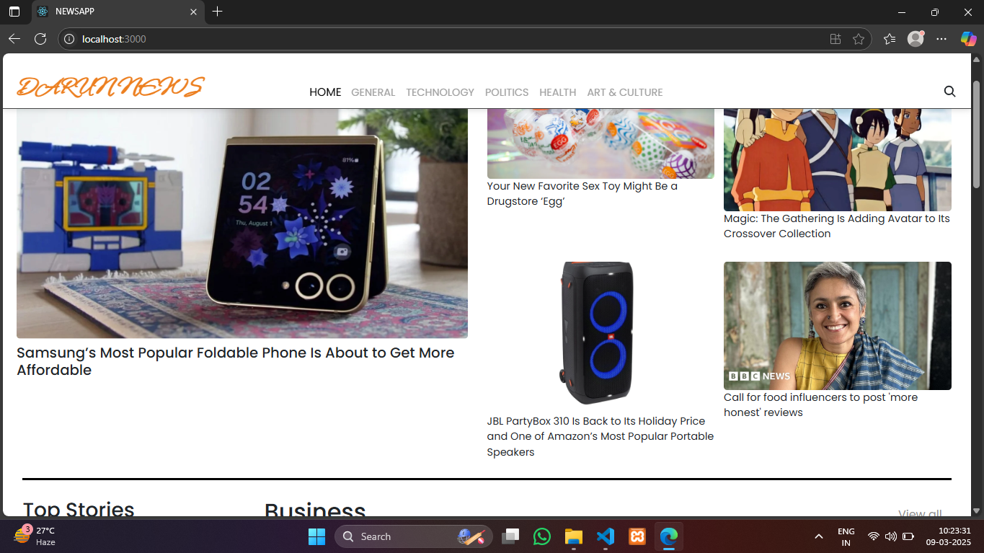

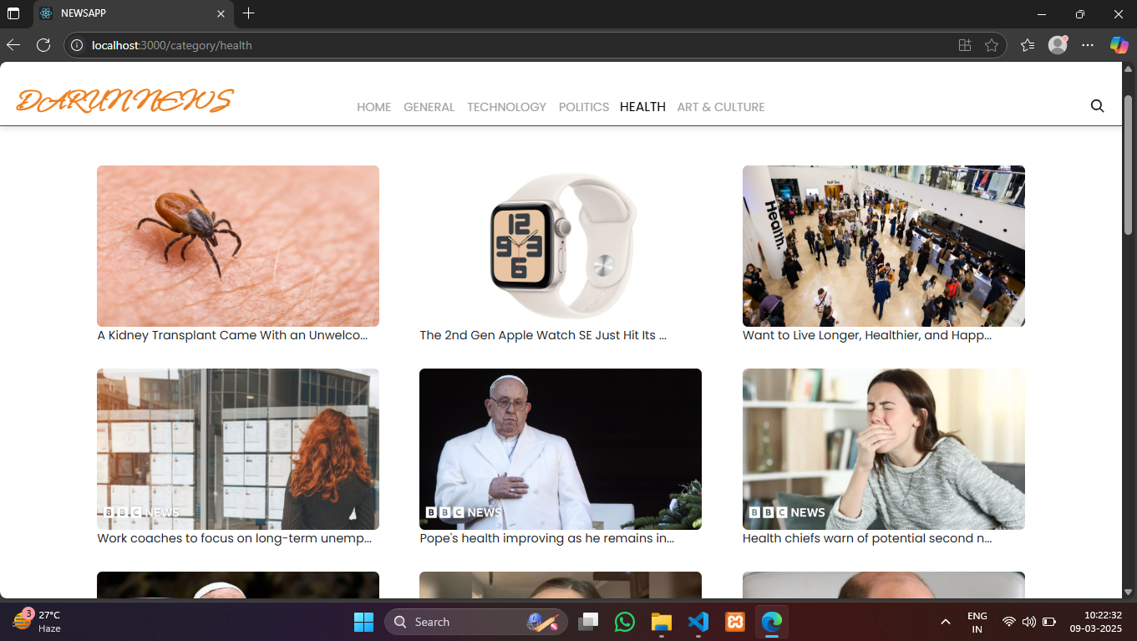

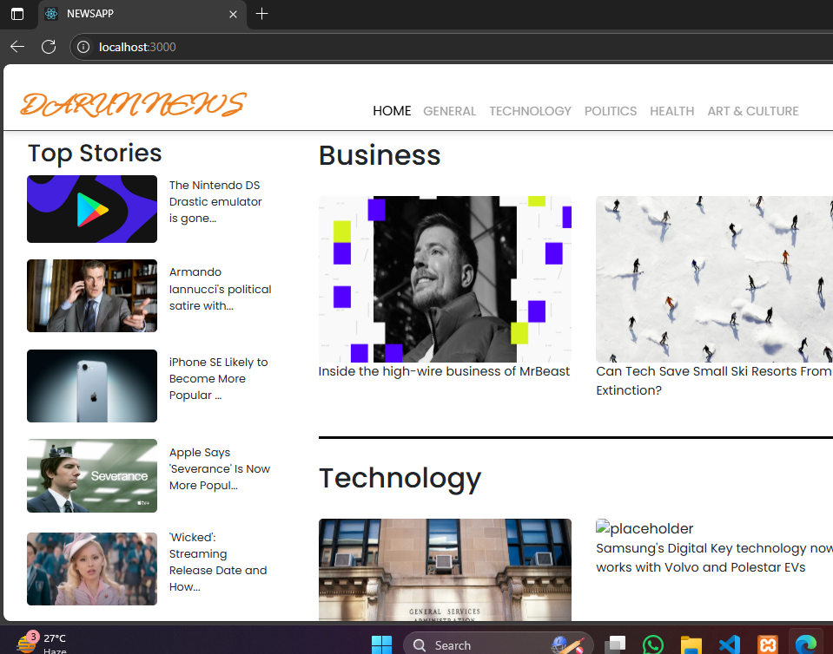

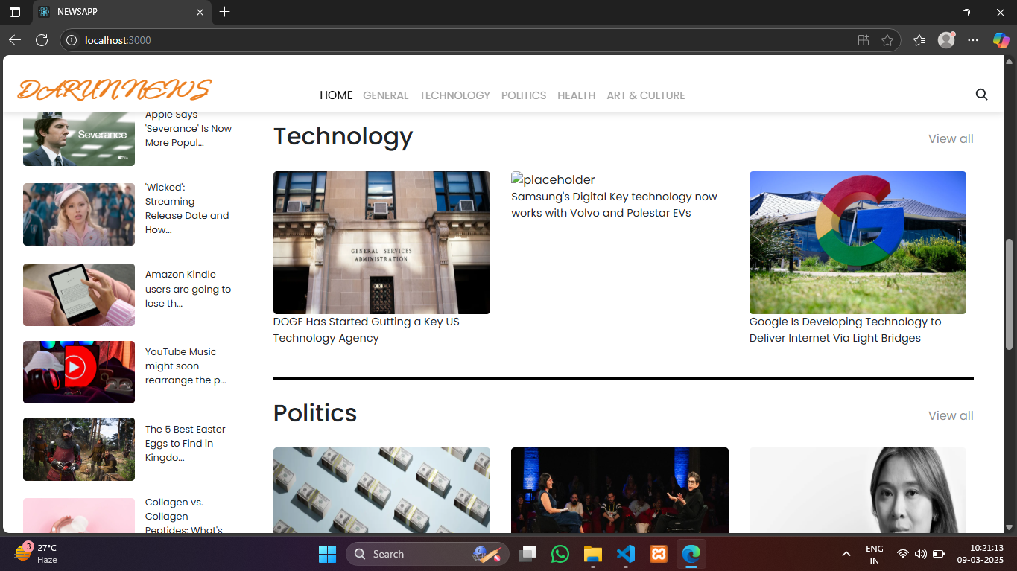

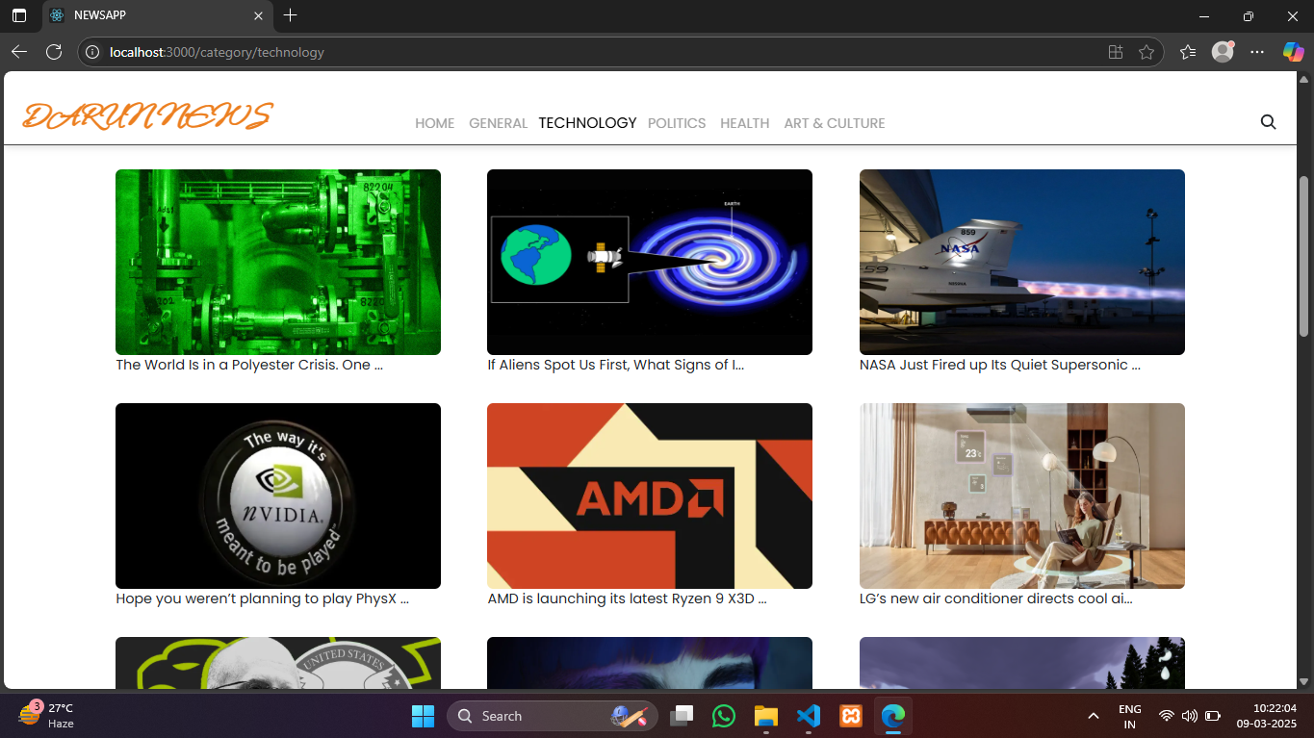

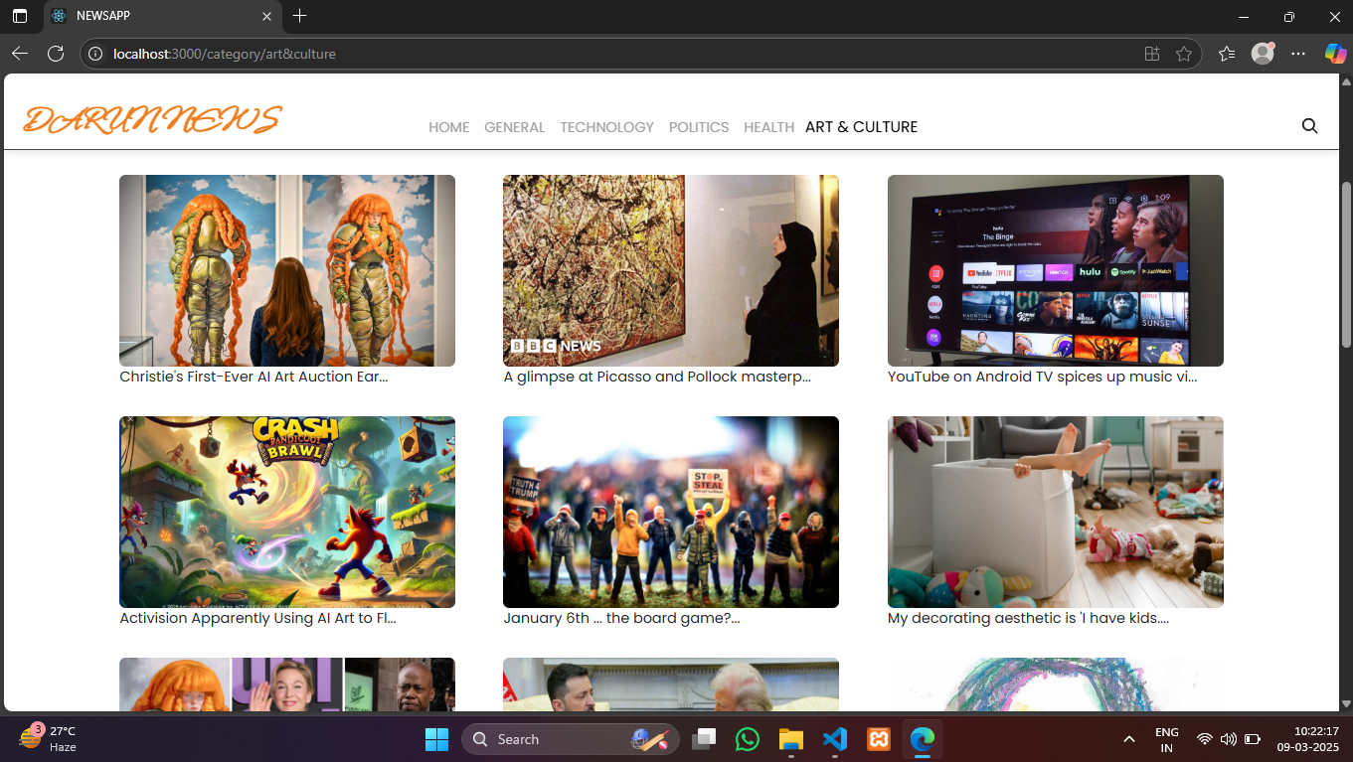

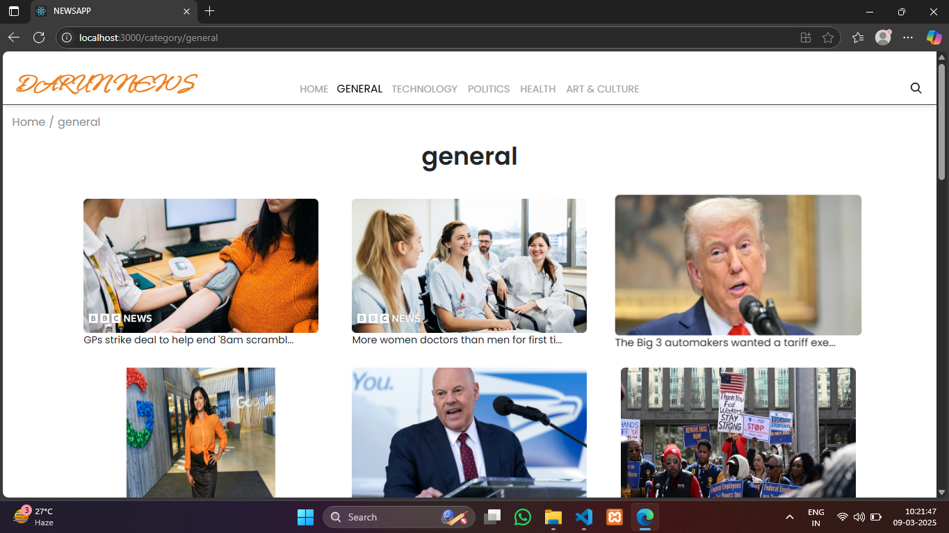

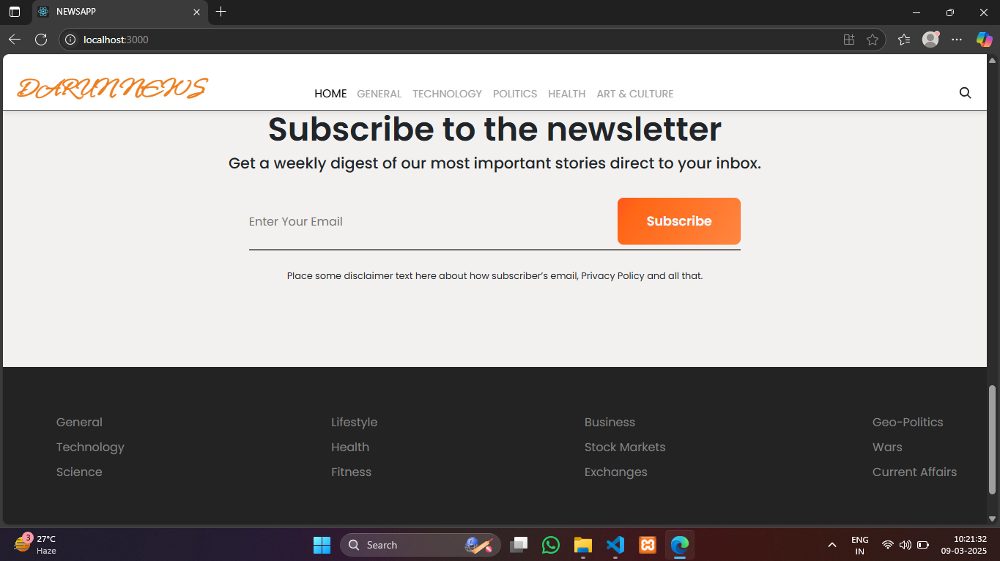

**Live Demo Link:** **https://drive.google.com/file/d/1pCSXKXBwaqxFtTbtjy5UojJv2Jaikrcr/view?usp=drive_link**

# 13. Known Issues

- Certain API endpoints may have limited access for free plans  
  
- Bookmark feature may require additional optimization for large data sets

# 14. Future Enhancements

- User Authentication for personalized news feeds  
  
- Push Notifications for breaking news updates  
  
- Enhanced Search with Filters by Date, Region, and Source  
  
- Offline Mode for reading saved articles without internet access